DCA BMS Browser Access Guide

# References

## Authorization

## Training/Certification

## Equipment/Information

## Policies

## Related Procedures

# Security Considerations

# Procedures

Please note, screen captures are representative and may not be specific to this project.

* Internet Browser: The Schneider Electric Struxureware BMS can use any internet browser however the use of Microsoft Internet Explorer is recommended and setup below is based on this browser.
* Accessing the BMS
  + Type in the BMS server IP address including the port “:8080” at the end.
  + Example: http://192.168.0.0:8080 (this is not the actual address)
  + A Struxureware login window will appear.
  + Type in your username, password, and no domain (leave blank).
  + The first time you login, leave your password blank, you will be forced to change it.
    - Type in current, with is empty.
    - Type in new twice.
    - Click OK in the lower right, it can be hard to see.
* Java: The BMS requires installation of a Java for the browser to function.
  + This will occur automatically when you type in the server IP address to access the EPMS. You will receive security warnings. You will have to type in a Windows admin user level user name and password for the local computer to allow the installation of the Cab file to proceed.
  + To verify that Java Runtime Environment is installed is installed
    - Open the Windows Control Panel
    - Open Program and Features
    - Look for a program called Java (JRE), any version 7.55 or newer should work.
  + Java configuration
    - Navigate to the Java Control Panel by either choosing the utility in the Windows Start menu or by first going to the Windows Control Panel or choosing the utility there.
    - In the Java Control Panel, choose the Security tab.
    - Check or verify there is a check mark in the box next to, “Enable Java content in the browser”.
    - In the same window, click the “Edit site list…” button. A new, additional window will open.
    - Click the Add button and type in the IP address starting with http:// into the blank line.
    - Click Add to type in an additional address or OK when finished adding addresses.
    - In the warning window that pops up, click Continue.
* Trusted Sites: To allow Java and ActiveX to load in the browser the BMS “site” must be made a Trusted Site within Microsoft Internet Explorer.
  + From within Internet Explorer click on the gear below the red X in the upper right corner.
  + Choose Internet Option, likely the second from the bottom choice.
  + A new window with multiple tabs across the top will open, choose the Security tab.
  + Choose (click once) on the Trusted Sites (green check mark image) option.
  + Click on the Sites button.
  + In the new window that opens, type in the DCA BMS server address, starting with http:// into the blank labeled as, “Add this website to the zone:”
  + Click the Add button.
  + Do NOT check the box for, “Require server verification…”
  + Click the Close button and that window will close.
  + Click the Apply button and then the OK button and the Internet Options window will close.
  + Close and reopen Internet Explorer.
  + Try to navigate to the BMS again to verify access.
* Problems: If you experience difficulties or for further assistance contact the Amazon IPS-Controls team.
  + Current team members supporting the project are the team manager Bill Bauerle and Controls Engineer Brian Bacon.

Screens showing navigation to the Control Panel and installed programs to verify Java installation:

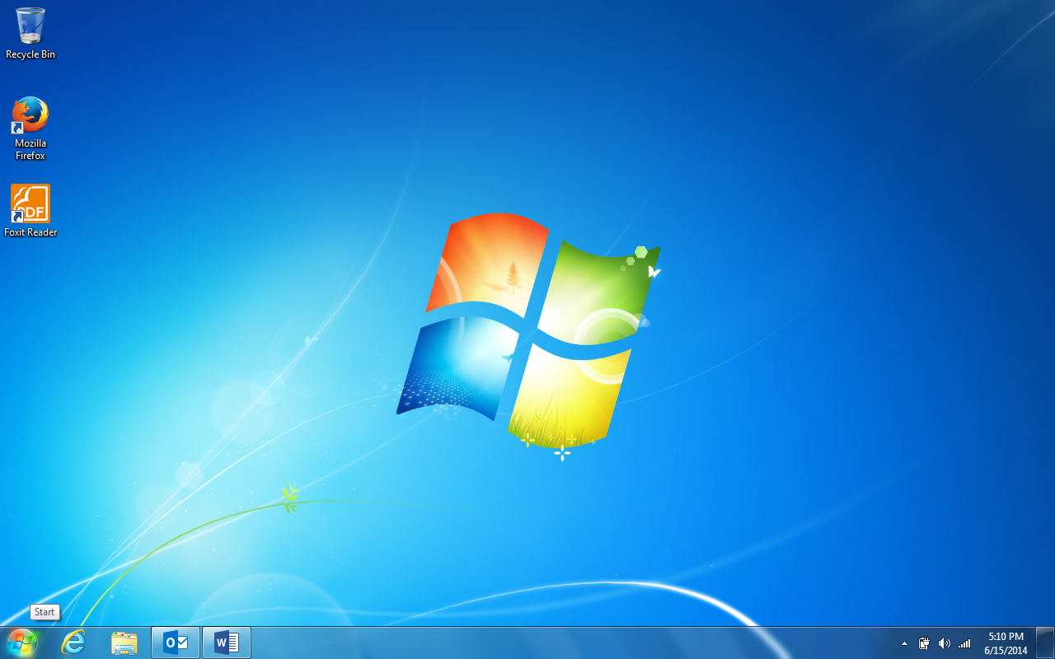

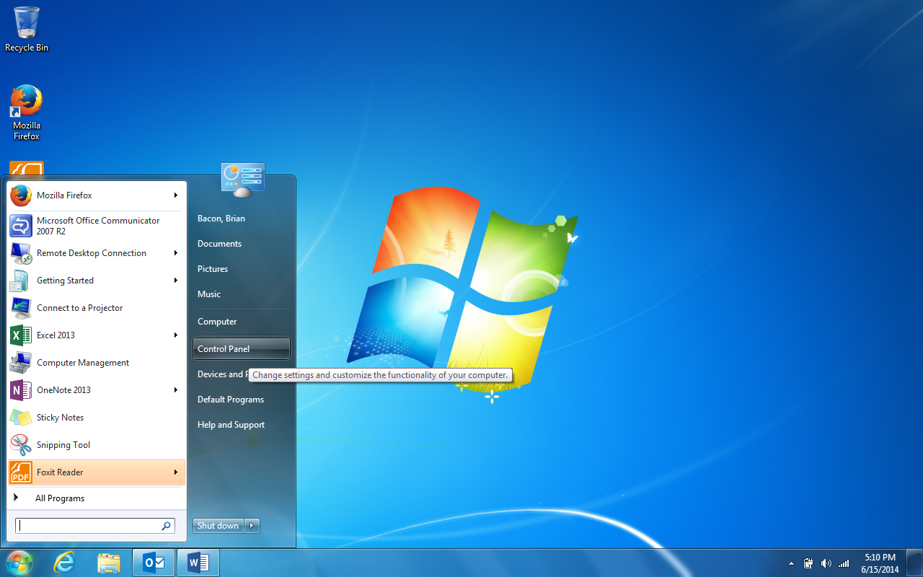

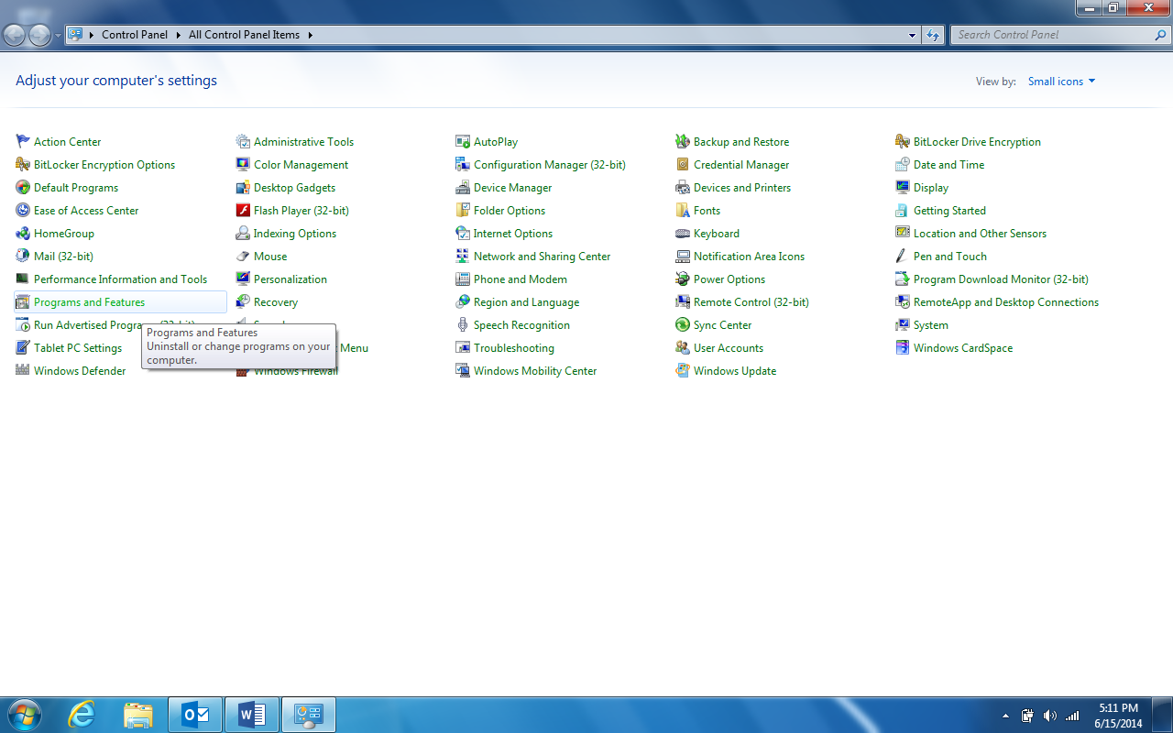

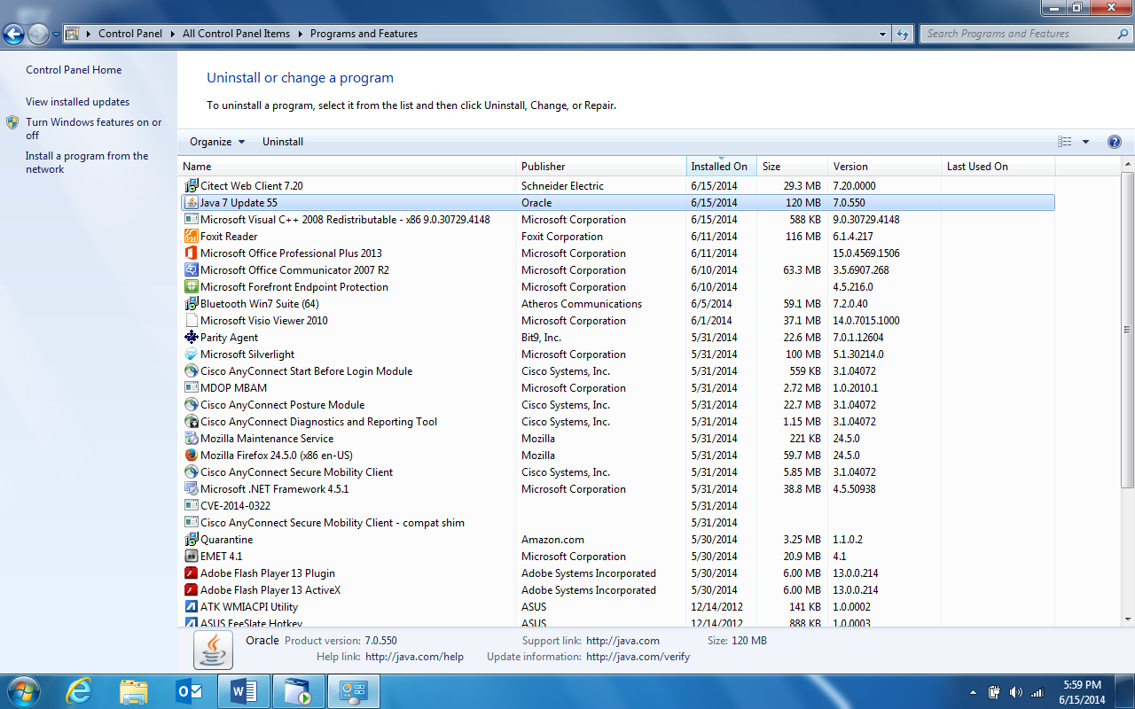

Screens showing Java setup:

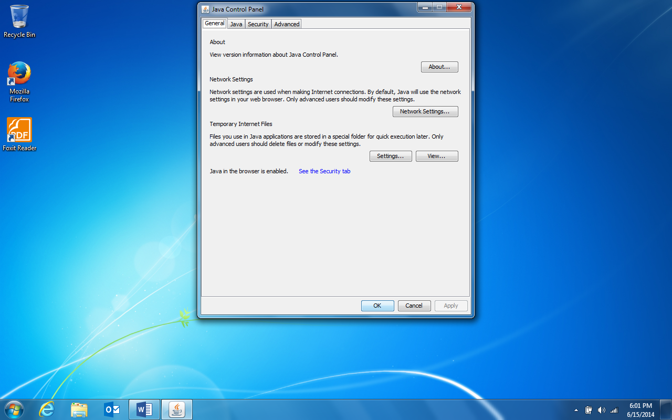

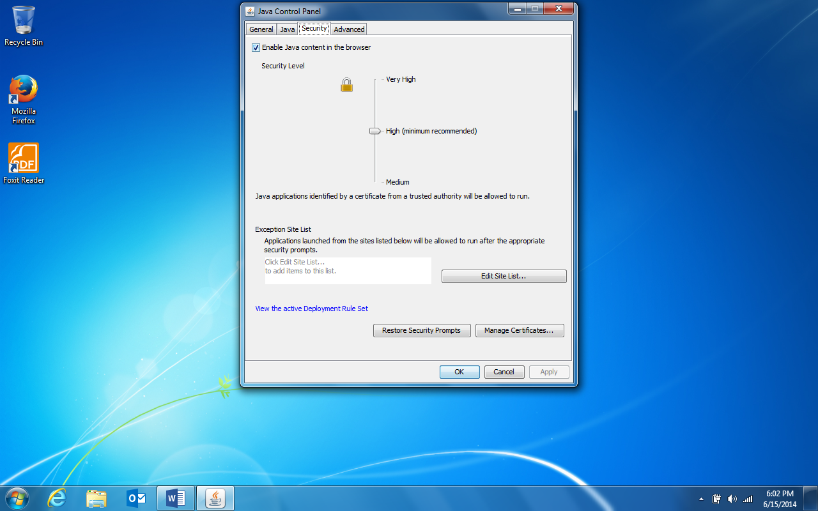

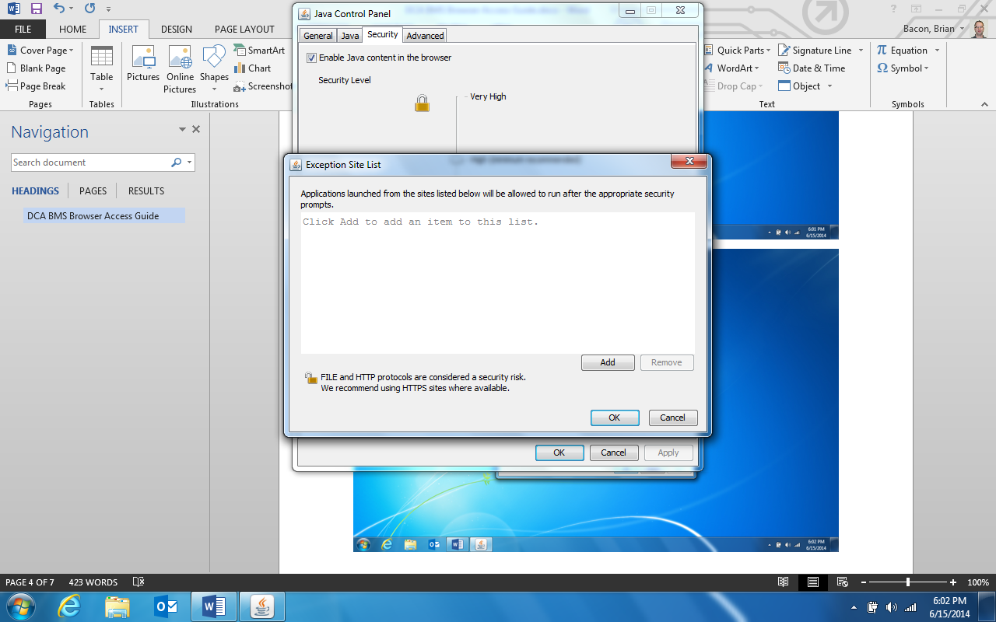

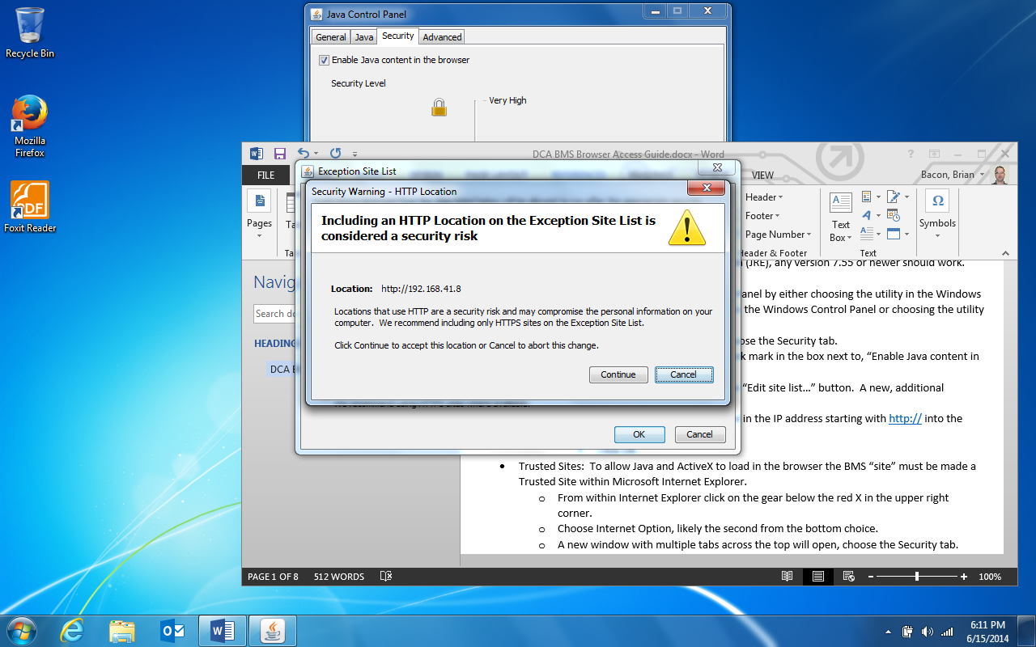

Screens showing navigation to Internet Options and Trusted Sites setup:

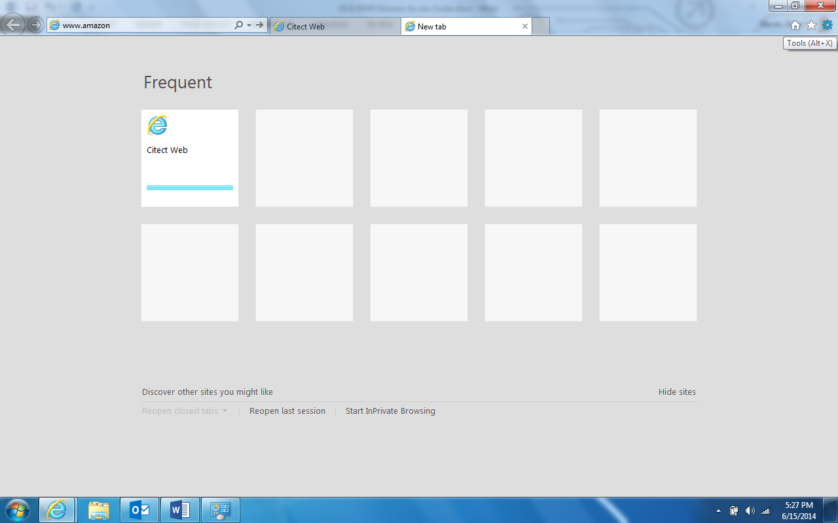

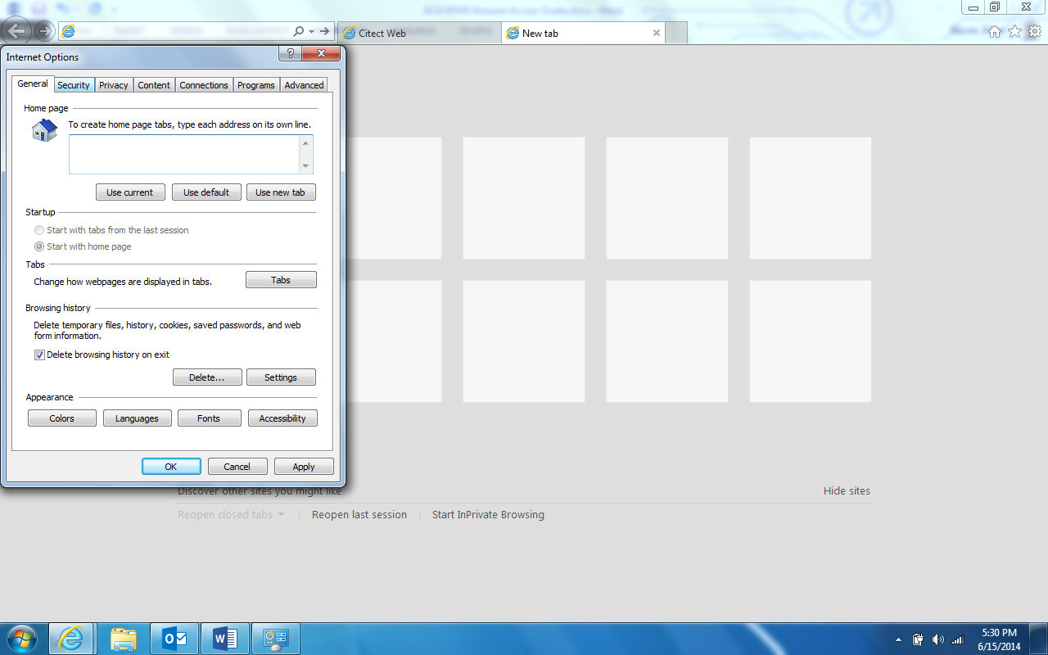

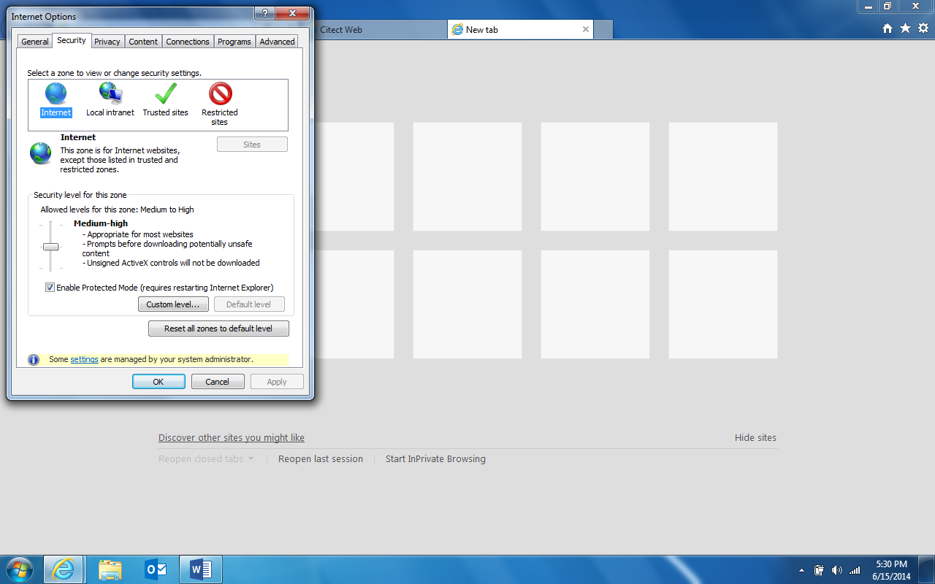

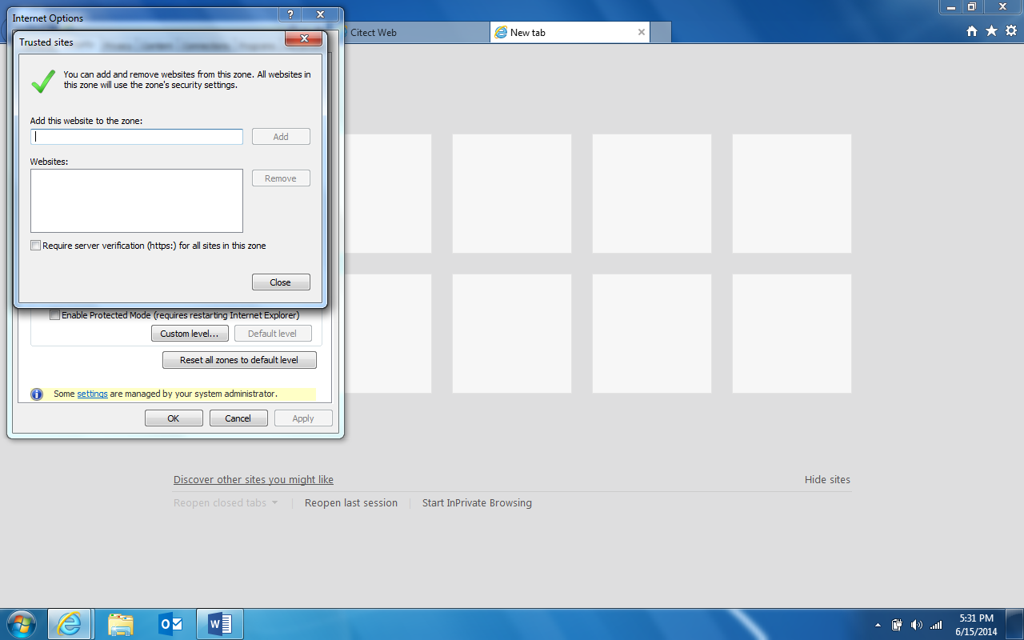

## Document Properties

|  |  |
| --- | --- |
| **Property** | **Value (replace explanation text with info)** |
| Site Code | DCA<#> |
| Filename | The EOPs and SOPs currently follow the format <scope>_<docType>_<description>. For example pdx_eop_rack-down |
| Title | For example, the Title for the filename above is "Emergency Operating Procedure Rack-Down Event" |
| Version number/Date version published | This may be automatically generated as a property of the doc (if it's in version control) or it may need to be added manually. |
| Doc Type | SOP/EOP/Checklist/Admin Practice/Form/Informational/Reference |
| Zone | What's the scope of the doc: Global, Regional, Cluster, Site |
| Technical Owner | Each doc needs an owner who is responsible for creating the draft and revising it as necessary. |
| Technical Writer | There should be a specific person from the publication side to manage the workflow, reporting, and publishing for each doc. |
| Affected Equipment | If we had a flag raised on a piece of equipment in an Agile, should this doc change? If so, list that equipment here. |
| Sensitivity rating | Public, Confidential, Highly Confidential, Critical. This might have to change for MVP. |
| Origin | Where did the "original" come from? For example, is it an MVP flavor of a commercial doc or is it from scratch.   * MVP Original * DCGS Unchanged * DCGS Changed * W * Twiki |
| URL | Where can techs view the most current version of the doc |
| Physical location | Where does the authoritative version of the doc live (eventually this is expected to be in Agile) |
| Audience | What role is this intended for. Data Tech, Electrical Engineer, Vendor, etc. |
| Renewal date | The date by which this doc should be reviewed by the technical owner (each month, each year, etc.) |
| Special requirements | What PPE is required for this work? |
| Safety considerations | What are the possible hazards the employee might be at risk of. |
| Physical requirements | Climb a ladder, lift over 50 lb., etc. |

## Status

|  |  |  |
| --- | --- | --- |
| **Status** | **Date mm/dd/yy** | **Approver/Reviewer Name** |
| Original filed |  | NA |
| Writer sent to SME for review |  | NA |
| SME sent to Writer |  | NA |
| Writer sent to SME for approval |  | NA |
| SME approved |  |  |
| Writer copy edited |  | NA |
| Site Manager approved |  |  |
| Regional Manager approved |  |  |
| Writer published |  | NA |